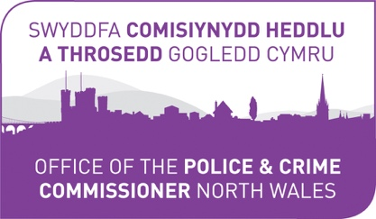

A joint initiative
of

The Police and Crime Commissioner for North Wales
and
North Wales Police

Your Community
Your Choice

Supporting projects that reduce crime and anti-social behaviour.

‘Criminals pain – Communities gain’

The Community Partnership Fund for North Wales 2020/21

APPLICATION PACK

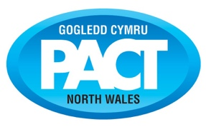
In association with
North Wales Police and Community Trust

Registered Charity Number 1071628

80236

Police and Crime Commissioner and North Wales Police

Your Community Your Choice

Introduction by Police and Crime Commissioner Arfon Jones and
Assistant Chief Constable Sacha Hatchett, North Wales Police

Once again we are delighted to be able to invite community organisations to apply to our annual ‘Your Community, Your Choice’ community fund. This will be the eighth successive year of our hugely successful fund.

Last year we sought applications that aimed to build resilient communities. This year we wish to continue that theme with proposals that aim to strengthen resilient communities by supporting our Police and Crime Plan - including proposals that address emerging trends such as County Lines and Knife Crime.

2020 has been extraordinarily challenging year for us all so we are pleased to announce that we are making £60,000 available to community groups across north Wales to support community projects that aim to keep our communities safe at this hugely difficult time. This may mean developing new and innovative ways of working and engaging with your communities and we look forward to hearing your ideas.

As you will be aware ‘Your Community, Your Choice’ is a joint initiative that has been made possible with funding from the Police and Crime Commissioner together with money made available through assets seized from criminals under the Proceeds of Crime Act. This would not be possible without the dedication and commitment of the oﬃcers and staﬀ of North Wales Police working tirelessly to bring criminals to justice.

We are encouraging community organisations to apply for funding for projects that will have a positive impact –particularly those which have a long-term vision reflecting the diversity of our area and working in collaboration with others to prevent problems occurring.

We particularly want to see proposals that help to prevent crime and anti-social behaviour in our communities and support the work of our Neighbourhood Policing Teams. When developing your proposal please consider how it will support the priorities of the current Police and Crime Plan which can be found on the Police and Crime Commissioner’s website www.northwales-pcc.gov.uk. We expect applicants to discuss their ideas with their local policing team before submitting an application.

Currently our five policing priorities are:
- Delivering Safer Neighbourhoods
- Domestic Abuse
- Modern Slavery & Human Trafficking
- Organised Crime Gangs – including addressing County Lines
- Sexual Abuse

The public will once again decide on which proposals are successful so you will need to ensure that your network of supporters get voting for you via the North Wales Police website when the voting period opens.

We would expect you to make contact with your local neighbourhood policing teams and work in partnership with them to develop your proposal - you will ﬁnd their details on the ‘Your Neighbourhood’ pages of the North Wales Police website www.north-wales.police.uk.

Thank you very much for your interest, we wish you every success with your application.

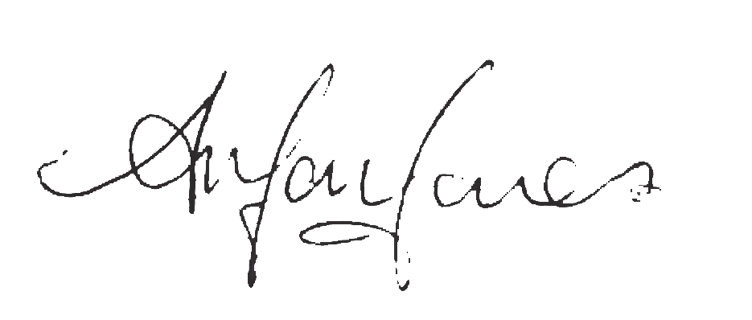

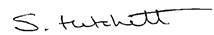

Arfon Jones Sacha Hatchett
Police and Crime Commissioner for North Wales Assistant Chief Constable

APPLICATION PACK
1

Mae’r ddogfen hon ar gael yn y Gymraeg.
80236

Please note the following Application Criteria and Guidelines:

1. ‘Your Community, Your Choice’ aims to support local community groups/organisations with funding, decided by a public vote, to develop new or existing projects that help to improve the quality of life in local communities.

All proposals are expected to support the current Police & Crime Plan, and encourage the development of positive working partnerships that help to support the current Police and Crime Plan (2017-21). You can ﬁnd the current Police and Crime Plan at: www.northwales-pcc.gov.uk

2. Maximum amount of application –
£2,500.00 for individual County applicants (Anglesey, Conwy, Denbighshire, Flintshire, Gwynedd, Wrexham)
£5,000.00 for pan-north Wales applicants (working in three or more counties). (NB additional question Number 23
for applicants in this category)

3. Applicants must be a properly constituted voluntary organisation, community group or charity working in north Wales. Town and Community Councils are also eligible. Please note: you may be asked to provide a copy your most recent set of accounts and/or most recent bank statement.

4. Applicants should indicate:

a) How your project will contribute towards reducing crime and anti-social behaviour in your area and support the priorities set out in the current Police and Crime Plan
b) Tell us how you have evidenced the need for your project and the problem that you are seeking to address
c) The beneﬁts which the project will bring to your local community
d) Who will beneﬁt from the project.
e) Ages of people involved in your project
f) Partners/agencies involved in/supporting your project
g) Applicants must discuss their application with the local policing team and receive the support of the district Inspector before submission.
h) Applications for CCTV will not be considered

5. Application must include a full ﬁnancial breakdown, giving speciﬁc details of how the funding will be spent - eg equipment, travel, staﬀ costs etc. Please indicate if you have obtained, or are in the process of obtaining,
any match-funding.

6. If any young people involved in your project are aged under eighteen, the group must have the support of adults and appropriate vetting procedures have been carried out. Please conﬁrm in your application that this has been obtained.

7. Previously successful applicants can apply but their proposal must be for a new and innovative piece of work.

8. If you wish to discuss your idea please contact Dave Evans on 01745 588516 or by email to:
yourcommunityyourchoice@nthwales.pnn.police.uk

9. Decisions of the panel and voting public will be ﬁnal. No correspondence about unsuccessful applications will be entered into. A maximum of four votes per household/ISP address will be allowed per project.

10. Closing date for applications: 12.00 noon,11th December 2020.

11. Projects must be completed, and grant monies spent, by 31st August 2021

12. Successful applicants will be required to sign and return our standard Terms and Conditions (Appendix A)

13. Please return the completed application form by Email to: yourcommunityyourchoice@nthwales.pnn.police.uk

Or by Post to:
North Wales Police and Community Trust
PACT Oﬃce, Ffordd William Morgan
St. Asaph Business Park, St. Asaph
Denbighshire
LL17 0HQ

APPLICATION PACK 2
80236

Your Community, Your Choice 2020/21

Grants:

County applicants:
Maximum amount of grant application £2,500.00
The three groups in each county with the most votes will be successful

Pan – North Wales applicants:
Maximum amount of grant application £5,000.00
The three groups with the most votes will be successful

Timetable
(dates may be subject to change)

Application period: Opens Closes | 16.11.21  11.12.21
Application assessments | Week commencing 14.12.20
Notiﬁcation to applicants of decisions | Week commencing 21.12.20
Public Internet Voting Period:  Opens  Closes  A maximum of four votes per household/ISP  address will be allowed per project | 08.01.21  29.01.21
Notiﬁcation to Successful Applicants  Cheque presentation event to successful applicants.  To be held at Police Headquarters, Colwyn Bay | Week commencing 08.02.21  February 2021

Please Note: Applicants will be advised should any dates change

APPLICATION PACK 3
80236

APPLICATION DETAILS

1. Organisation:

2. Address (including post code):

3. Contact Details

Name:
Position in organisation:
Email:
Telephone:
Mobile:

4. Title of Project:

5. Amount applied for:

6. Is this request for:

Total Funding: |  | Part/Match-Funding:

7. Please describe your organisation:
a) (If a Registered Charity or Community Interest Company please give your registration number)

b) When was your organisation formed

c) How many members are there on your committee/Board of Trustees?

d) How many people are needed to authorise a payment or sign a cheque?

e) If successful with this application please advise who our cheque should be made payable to:

APPLICATION PACK 4
80236

8. Your project:
Please describe the activities or services you are asking us to fund AND what problem you are seeking to address Please tell us what difference your project will make to your community, the problems it aims to overcome and how it will help to strengthen resilient communities (Please indicate the outputs and outcomes your project will achieve) (MAX 500 words)

5 80236

9. Please tell us which current Police and Crime Plan priority your project aims to support and how it will do this:
(MAX 500 words)

APPLICATION PACK 6 80236

10. How have you identified the need for this project? (Please include evidence}
(MAX 500 words)

APPLICATION PACK 7 80236

11. Where will your project take place?
(please also indicate the County / For pan-north wales applicants: please conﬁrm the areas and counties you will be working in)

12. When will the project take place?
(please indicate start/end dates)

13. How many people will be involved in the delivery of your project?
(please include age-ranges)

14. How many people do you anticipate will beneﬁt from your project?
(please include age range)

15. Does your project address the needs of any particular group?
(Please indicate how)

16. You will need to discuss your project with your local Neighbourhood Policing Team, and obtain the support and endorsement of your District Inspector.

Tell us how you will work with your local policing team in the delivery of your project.
Please conﬁrm details of discussions including oﬃcers concerned
Your proposal will require the support of your district police Inspector – Section 17
(Max 200 words)

APPLICATION PACK 9

17. District Inspectors Comments/Endorsement

80236

18. Working in Partnership: Please indicate which other partners/agencies will be involved in your project and their roles.

19. Please tell us how will you monitor and evaluate your project
(Max 200 words)

APPLICATION PACK 10
80236

20. If your application is successful, what will happen to your project after this funding has been utilized?
(Max 200 words)

21. Project Costs
Please give a full breakdown of all costs. Please include approximate value of any in-kind support obtained. If your project costs are greater than £2,500 (£5000 for pan north-Wales projects) please indicate which items our funding would be used for.

Item | Cost
TOTAL | £

APPLICATION PACK 11
80236

22. Have you secured funding from any other funder(s).
If so, please indicate to whom, how much you have received.

FOR APPLICANTS APPLYING FOR A GRANT OF £5,000

23. Please tell us which counties you will be working in and your organisations ability to deliver your proposal and the structure in place to support local communities.

(Max. 300 words)

APPLICATION PACK 12 80236

APPENDIX A
The following Terms and Conditions will apply to all successful applicants
This document must be signed and witnessed and returned prior to any funding being received.

TERMS AND CONDITIONS FOR PROJECT FUNDING

1. The ‘Project’ means the project or activity that the Funder has agreed to give you a grant for as set out in your application form together with any supporting documents such as budget information, a timetable and any other documents that set out how your Project will be managed.

2. The ‘Funder’ means jointly the Police and Crime Commissioner for North Wales and North Wales Police

3. ‘You’ means the organization that the Funder has given a grant to.

4. The grant may only be used for the Project.

5. You must start the Project within one month of receiving the grant payment from us.

6. You must make satisfactory progress with the Project and complete it on time.

7. You must tell us immediately if anything threatens to curtail or delay the Project.

8. You must tell us if you receive any other funding for the Project from any other source at any time during the Project. If this means that you no longer need the funding from us, you must pay the grant back to us immediately upon demand from us.

If you spend less than the whole grant on the Project, you must return the unspent amount to us promptly. If the grant part-funds the Project, you must return the appropriate share of the unspent amount to us.

9. You must write to us as soon as possible if any legal claims are made or threatened against you and/or which would adversely aﬀect the Project during the period of the grant (including any claims made against members of your governing body or staﬀ concerning the organisation).

10. If you are an unincorporated group, you must provide us with written evidence that the person signing below has the authority of the group to enter into the Grant Agreement on behalf of all the members of the group and that all members of the group will be jointly and severally liable under the Grant Agreement.

11. You must tell us in writing as soon as possible of any investigation concerning your organisation, trustees, directors, employees or volunteers carried out by the Police, Charity Commission, HM Revenue & Customs or any other regulatory body.

12. In carrying out your Project, you must meet all laws regulating the way you operate, the work you carry out,
the staﬀ you employ or the goods and services you buy. For example, you are responsible for getting any licences,
permissions and insurances that are necessary by law.

13. A clear ﬁnancial summary, which shows how the grant has been spent, shall be compiled and supplied to the Funder. All invoices, receipts and accounting records relating to the expenditure of the grant will be made available at any reasonable time for inspection or audit by the Funder.

14. A simple record of the project’s development, supported by photographs, should be maintained and will be made available at any reasonable time for inspection by an oﬃcial of the funder.

15. You are required to contact the North Wales Police Press and Media Department and provide details of the initiative PRIOR TO ANY EVENT ASSOCIATED WITH THE PROJECT.

Press releases and all publicity material MUST always include reference to the ﬁnancial support provided by:
The Police and Crime Commissioner for North Wales and North Wales Police

16. You must ensure that all reasonable steps have been taken to ensure that any adult assisting with the project has successfully complied with the relevant security and safety checks if working with children and young people.

17. The Funder is purely a grant-making organisation and is not responsible for any acts or omissions of those taking part in the projects and schemes. Such responsibility rests with those who organise the projects and schemes. You are required to consider carefully your legal responsibility as organiser and to take out any insurance cover considered by you to be appropriate.

APPLICATION PACK 13
80236

We may recover the grant in our absolute discretion, if any of the following events occurs:

17.1 you close down your business (unless it joins with, or is replaced by, another business that can carry out the Project and we have provided our prior written permission);

17.2 you make any changes to the Project without ﬁrst getting our written permission;
17.3 you use the grant for anything other than the Project;
17.4 you do not follow our reasonable instructions;
17.5 you do not carry out the Project with reasonable care, thoroughness, competence and to a standard that would be expected for your level of experience in your artistic practice, profession or line of work;
17.6 you do not complete the Project;
17.7 you have supplied us with any information that is wrong or misleading, either by mistake or because you were trying to mislead us;
17.8 you are declared bankrupt or become insolvent, any order is made, or resolution is passed, for you to go into administration, be wound up or dissolved; an administrator or other receiver, manager, liquidator, trustee or similar oﬃcer is appointed over all or a considerable amount of your assets; or you enter into or propose any arrangement with the people you owe money to;
17.9 you act illegally or negligently at any time, and we believe it has signiﬁcantly aﬀected the Project, or is likely to harm our or your reputation; and/or
17.10 without ﬁrst getting our approval in writing, you sell or in some other way transfer the grant, your business or the Project to someone else.

18. These terms and conditions and the Grant Agreement remain in force for whichever of these is the longest time:

• for one year following the payment of the last instalment of the grant;

• as long as any part of the grant remains unspent;

• as long as you do not carry out any of the terms and conditions of the Grant Agreement or any breach of them continues (this includes any outstanding reporting on grant expenditure or Project delivery.

19. The Freedom of Information Act 2000 (‘the Act’) applies to us. This means that any information you give us could be released to any person who asks for it under the Act. You must tell us if you think that any of the information should be conﬁdential under any of the exemptions of the Act. Please visit www.ico.gov.uk/ for information on
the Act.

Proof that these conditions have been complied with may be required.

Name of Organisation …………………………….................................……............................................................................................................................................................………………. (PRINT FULL NAME) I …………………………….................................…….............................................................................................................................................................………………. have read the above terms and conditions and on behalf of the project team agree to abide by them.

Signed: …………………………….................................…............................……………...................................……. Date: …………………………….................................…............................………………….

(PRINT) Position in organisation: ……………………………......................................................................................................…............................……………...................................…….

Witnessed by: (Signature) …………………………….................................…..................................................................................................................……………...................................……. (PRINT) Full Name: ……………………………........................................................................................................................................…............................……………...................................……. (PRINT) Position in organisation: ……………………………......................................................................................................…............................……………...................................…….

PLEASE RETURN THIS SIGNED DOCUMENT TO:-

North Wales Police, PACT Oﬃce. Ffordd William Morgan. St Asaph Business Park. St Asaph. Denbighshire. LL17 0HQ

APPLICATION PACK 14
80236

In association with
North Wales Police and Community Trust

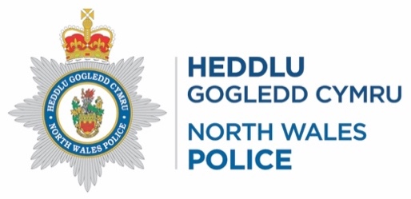

Registered Charity Number 1071628

80236

